**CHAPTER TWO**

**LITERATURE REVIEW**

* 1. **Introduction**

Artificial intelligent frequently called AI denote the field of sturdy that make computer mimic intelligent behaviors or task of humans or animal. The lifestyle of humans as change drastically since the invention of artificial intelligent in recent years (Zhang & Lu, 2021). The strategy for developing artificial intelligent system has been areas of interest in most country around the world today, for improving their security system, and automating market competitive strategy. AI has also captures the heart of many researchers due to vast numbers of unresolved problem in the field. Big company such has Google, IBM, and Microsoft are fully investing in artificial intelligent to solve many problems. Artificial Intelligent technology research field is made up of many discipline, which are capable of merging cognition, emotion recognition, machine learning, human computer interaction, decision-making and finally data storage (Nistor et al., 2021).

* 1. **Natural language processing**

Natural Language Processing which can be shortly refers to as NLP illustrate the ability of computers or machine to identify, recognize, and comprehend text or spoken languages. It’s the interdisciplinary field consisting of computer science and human linguistics (Zhang & Lu, 2021). Moreover, the field natural language processing can be broadly classified into seven groups, this includes

1. Sentiment and Grammatical analysis
2. Information extraction
3. Text mining
4. Information retrieval
5. Machine translation
6. Dialog system
7. Question and answering system

Furthermore, NLP can be define as the technological concept that uses natural language to interact with computers (Zhang & Lu, 2021). The basic of natural language processing is to enable computer system to understands the natural spoken words. This includes the conjunction of linguistic processing and artificial intelligent. NLP technology takes sounds as inputs and convert those sound signal into text signals and semantic of the text signal, then from text to words along with their semantic. Finally, the computer or machine can hear and comprehend the words. Text classification is tag as the most basic task or problem we solve in the field of natural language processing. The process of mapping pre-defined label for text is an important task in various NLP applications this includes; sentiment analysis, topic labeling, dialog act classification, question answering and lot more (Li et al., 2020)

* 1. **NLP feature Extraction**

Feature extraction denote the approach used in converting textual data into understandable numerical data, which can be easily understand by the machine. The primary aim of this techniques to create a vocabular and vector representation of words for easy machine learning. They are numerous way and method used in creating features in NPL , this includes; One Hot Encoding, Hashing Vectorizer, TFIDF Vectorizer, Count Vectorizer, Word Embeddings (Irawaty et al., 2020).

* + 1. **Hashing Vectorizer**

The Hashing Vectorizer uses the hash function to efficiently map terms or vocabulary to features. In Hash Vectorizer the Hash Function is used to calculate each document frequency, and the method transform the textual document onto an event matrix of tokens (Irawaty et al., 2020).

* + 1. **TF-IDF Vectorizer**

The acronyms TF-IDF is refers to has term frequency-inverse document frequency. The method of vectorization uses a statistical measure to extract the important of each vocabulary word in a document. However, TF denote the frequency of a word in respect to a dataset, while the Inverse Document frequency (IDF) compute how widely each term weight is distributed over the enter corpus. Comprehensively, the smaller the term in a document the greater or larger the value of the Inverse Document Frequency (Irawaty et al., 2020). In other sense, the TF-IDF is one of the method used in computing word frequencies by attaching the TF-IDF score of each word in a document (Poddar et al., 2019). The TF and IDF explicitly means

1. **Term Frequency (TF):** This denote the frequency of individual word of the vocabulary in the document.
2. **Inverse Document Frequency (IDF):** The include penalizing each word by checking for the number off occurrence across all document in the corpus.

The algorithm tries to pinpoint vocal that are significant (appear most) in a giving document using the frequency of the word. Technically, the vectorizer approach extract tokens from the document, generate learned vocabulary with the inverse document frequency weightings, and finally produce a new document (Poddar et al., 2019).

* + 1. **Count Vectorizer**

In Count Vectorizer a matrix of word or token counts is generated from a textual document. The vectorization techniques present data science developer an easy approach to transform the collection of textual document and developed a vocabulary containing unique words (Irawaty et al., 2020). In count vectorizer an encoded vector with the size of the numbers of vocabulary is generated, each instance represent the frequency of each word in respect to the document (Poddar et al., 2019).

* + 1. **Word Embeddings**

Word embedding is a technique use in represent words in numeric format and also preserve or encode the contextual meaning of words. They are various word embedding techniques this includes; Word2Vec, GloVe, and BERT (Sinan & Kayaalp, 2021).

* 1. **Deep Learning**

Developing a deep learning model requires large amount of training data in comparison to machine learning algorithm (Searle et al., 2020). The Deep Learning neural network is made up of artificially developed neural networks to mimic the human brain functionality in an automated manner. In deep learning high level feature extraction from data are automated, this result in better result than that of the traditional machine learning model. problems that require deep learning algorithm includes; speech recognition problems, text understanding, and image recognition and processing. Various type of input data are analyzed by the network for classification to occur on the dataset, such input data includes a single labeled data, unsupervised dataset, multi labeled data, unbalanced dataset (Li et al., 2020). Various deep learning algorithm has been proposed and developed by data scientist in the last few decades, this includes; Recurrent neural network, Convolutional Neural Network, LSTM, Gated Recurrent Unit, BERT, Deep Neural Networks and many More.

* + 1. **Convolutional Neural Network (CNN)**

Convolutional neural network is one of the deep learning algorithm that is based on the human biological neurons (visual cortex). The convolution operation is the basic building block of the CNN, which resulted in weighted interoperability of is input function (Torfi et al., 2020).

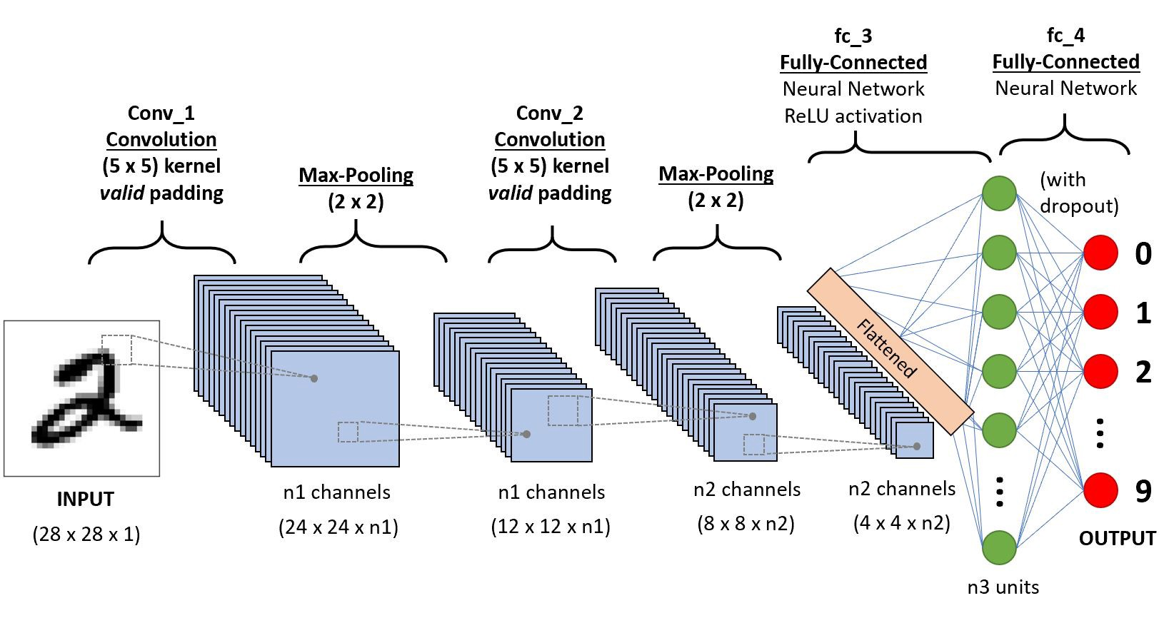

**Fig 2.1. The Convolutional Neural Network Architecture**

* + 1. **Feed Forward Neural Network (FFNN)**

The feed forward neural network architecture depicts the basic general neural network structure. Information are transported within the FFNN chain ranging from the input layer to the hidden layers and finally down to the output layer. However, the output of all layer except the last layer serve as an input to the subsequent layer (Goyal et al., 2018).

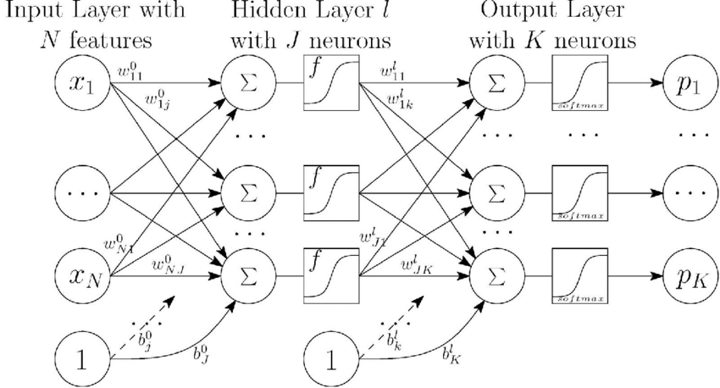

**Fig 2.2. The Feed Forward Neural Network Architecture**

* + 1. **Recurrent Neural Network (RNN)**

The Recurrent Neural Network architecture constitute are series of feed forward network sequentially arrange in a way that the output of one network is the input of the next network. Similarly, like the other neural network architecture the layers of then network contain input layers, hidden layers and the output layers. A set of input vectors with a specified dimension are feed into the input layer in a discrete time frames on vector at a time. Internally the network carry out some basic operation such as updating the weight of the network, and feeding weight to the next layer as inputs (Torfi et al., 2020).

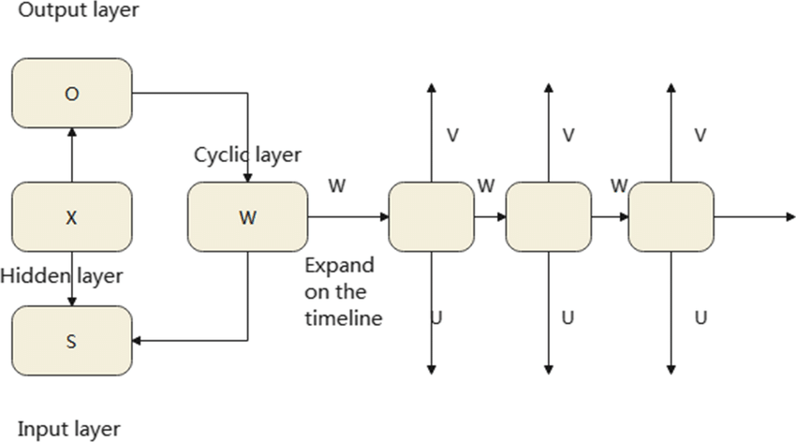

**Fig 2.3. The Recurrent Neural Network Architecture (Nistor et al., 2021)**

* + 1. **Long Short-Term Memory Network (LSTM)**

The Long Short-Term Memory is simply called LSTM, this network is design as a result of flaws identify in RNN (vanishing gradient problem). The deep learning techniques is design to hold longer time weight or information of input from different times step. Moreover, modern natural language task such as Machin translation and speech recognition highly depends on LSTM network (Torfi et al., 2020).

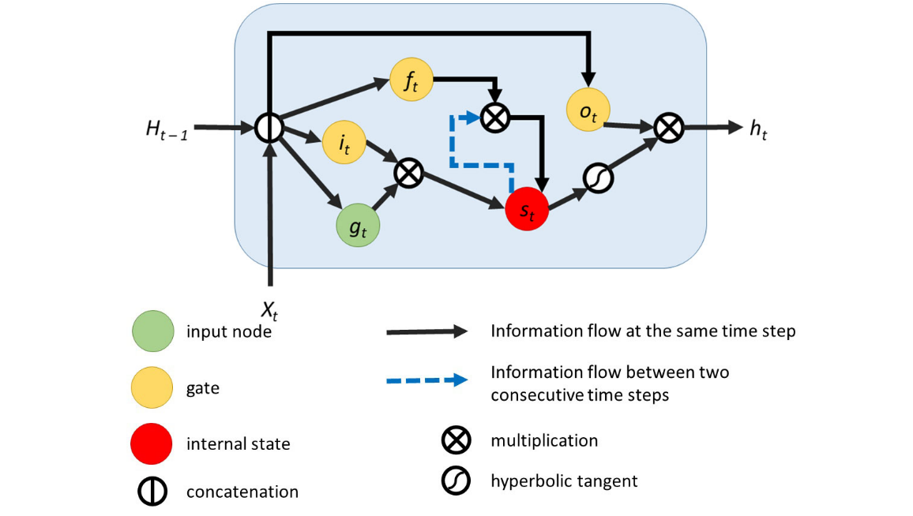

**Fig 2.4. The Long Short Time Memory Architecture (Nistor et al., 2021)**

* + 1. **Gated Recurrent Unit (GRU)**

The Gated Recurrent Unit (GRU) is a simpler version architecture of the Long Short-Term Memory (LSTM). It contains minimum learnable parameters and use only two gates. Moreover, its developed to attain performance solution and it has been utilized for solving many all NLP task (Nistor et al., 2021).

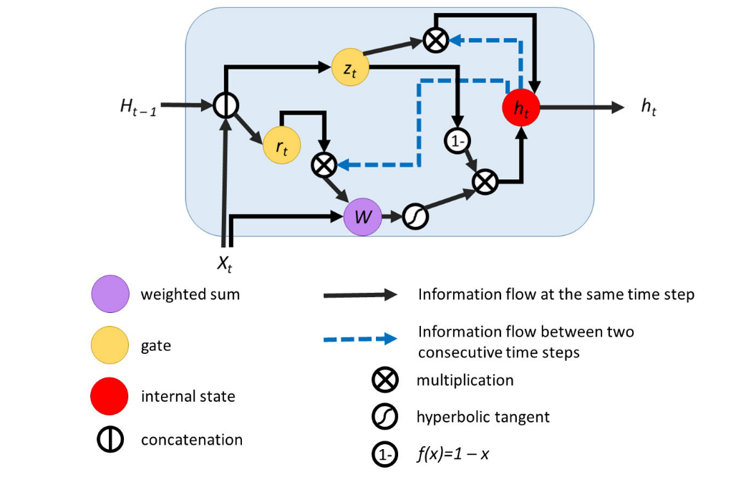

**Fig 2.4. Gated Recurrent Unit (Nistor et al., 2021)**

* 1. **Sentiment analysis**

All domain in the social life are been touched by the social media in today’s word. Information are being distributed among people for better understanding and to ensure awareness of thing going on around them, such as the places, news, events, services or products. A social media blog like twitter enable people (users) to express or share feeling across the globe. The idea of knowing what other people feels (sentiment) about a product or services rendered, is crucial for efficient decision making (Nistor et al., 2021). Sentiment analysis is purposely for opinion extraction in a large corpus, it also includes extracting how people perceive ideas, product, event or even services rendered on social media site such as twitter. Sentiment analysis can also be taking as examine people’s emotion or point of view about or towards something (Shitole, 2021)

* 1. **Related Work**

According to the paper work of (Nazeer et al., 2020), titled Use of Novel Ensemble Machine Learning Approach for Social Media Sentiment Analysis. The researchers stated that twitter is a platform where the users can express there feeling and opinion. It has also become a major respiratory where many sectors get their data and then later analyzed it for sentiment. According to the researchers, many machine learning algorithms are available for twitter sentiment analysis which can be used for predicting the sentiments of tweets automatically. However, there are disadvantage that affect the machine learning classifiers to achieve an outstanding performance in term of classification. In this paper the authors proposed a novel feature generating technique to produce desired features for tanning model. This novel ensemble classification system classifier, which make use of many commonly used statistical model like naïve Bayes, random forest, and logistical regression which are weighted according to their ability on historical data, where weights are chosen differently for each model. The researchers then concluded that in future, the proposed ensemble model will not participate in tanning the dataset for classification of sentiments. The model will then be extended by the use of optimization algorithm for further refining the future se for outstanding performance in term of classification in sentiment analysis.

Reviewing this article by (Wang et al., 2020) , which is been titled Tree-Structured Regional CNN-LSTM Model for Dimensional Sentiment Analysis. According to the authors a research is been done on dimensional sentiment analysis, in which dimensional sentiment analysis aim to identify continues numerical values in double dimensions such as the valence-arousal (VA) space. Matched to the categorical approach that aim on sentiment classification such as binary classification (positive and negative), the dimensional approach can give a better sentiment analysis. In this paper the research proposed a tree-structured regional CCN-LSTM model with two parts: regional CNN and LSTM to predict the VA performance of texts. Unlike a conventional CNN. The proposed regional CNN make used of some text as region, by dividing an input into many regions so that the useful information in each region can be extracted and weighted their advantage to the VA prediction. It’s been concluded that in other to further improve the performance, a region division approach is proposed to discover task-relevant phrases and clauses to combined structured information into VA prediction. The experimental result on different corpora shows that the proposed method outperforms other methods.

In this paper (Raisa et al., 2021) title A Review on Twitter Sentiment Analysis Approaches. According to the researcher it is been stated that sentiment analysis solves the problem of interpreting data presented in different format and realm in term of feelings and opinions. Sentiment analysis is also needful to different sectors that need awareness of the view of people on their products or other cases. Twitter is among the most widely accepted social platform and widely used platform site where people can express their mind, view and opinions, which make this space an outshine tools for analyzing sentiment. The authors reviewed the work done by other researchers in which the reviewed work is separated according to their implementation classification algorithms. A contrastive analysis on different approach and method of sentiment analysis using Twitter data in the review article. Also result analysis, research gaps, and future scope of twitter sentiment are tackled.

In this article (Shitole, 2021) titled Twitter Sentiment Analysis Using Supervised Machine Learning. The researcher stated that sentiment analysis aims to figure out opinions, attitude, and also emotions from different social media site such as twitter. In the recent years twitter has become the most popular research area. The main focus of the conventional way of sentiment analysis is on textual data. According to the researcher twitter is the most popular smallblooging online networking site in which the users post updates about different topics in form of tweet. In this article the authors make use of label dataset which is publicly available on Kaggle, and also a well arrange pre-processing algorithm which make the tweets manageable to the normally used language plan is structured, in which each example in the dataset is a pair of tweet a sentiment. So, the supervised machine learning is used to support the sentiment analysis models based on naïve Bayes, logistic regression, and support vector machine are proposed. In this paper the researcher main goal is to break down sentiments adequately. In the twitter sentiment analysis tweet are categorized into positive and negative sentiment. The researcher concluded that higher accuracy is obtained by using sentiments features instead of conventional text classification. In which the feature can be utilized by various sector.

Reviewing the work of (Machuca et al., 2021) titled Twitter Sentiment Analysis on Coronavirus: Machine Learning Approach. In this paper the author stated that the main challenges in machine learning is the analysis of data to identify feelings using algorithms that allow us to identify a bad feeling from good ones in a tweet. Social network is a vital source of getting information, which is been used to express personal point of view and ideas. Based on this article the researchers proposed a sentiment analysis of English tweet at the time of pandemic COVID-19 in 2020. According to them the tweet where categorized as good or bad by applying the Logistic Regression algorithm, using this method the authors got a classification accuracy of 78.5%. In this paper the researcher’s focus on the analyzing people’s behavior to the pandemic. The main goal is to find out whether the sentiment of the public opinion is positive or negative by using machine learning algorithm and natural language processing techniques. Even though that the analysis figures out variation of ideas. It seems that the users mostly remain positive about the pandemic. The month of January is the only month in which negative ideas is much than the positive ideas, then march is the month when the COVID-19 disease was announced as a pandemic and several countries started to apply percussion measures, due to the rise of positive thought. To make it short, 54% of the people showed positive feelings and 64% of the people showed negative feelings.

(Model et al., 2021)

(Model et al., 2021), tiled A Novel Word-embedding Method for Real-time Sentiment with Integrated LSTM-CNN Model. According to them, Artificial intelligence (AI) is a focused research area technology in which Natural language processing (NLP) is a vital technology in Artificial intelligent. It is also stated that sentimental analysis goal is to absorb and classify the people’s idea by Natural language processing (NLP). The machine learning and lexicon dictionaries have less power to efficiently analyze large live media data. In the last few years, deep learning method have successfully improved the accuracy of recent sentiment models. However, the existing method provide the part that reduces each word accuracy if a sentence doesn’t follow the information in real-time. Therefore, the authors proposed a novel word embedding method for the real-time sentiment (WRS) for word representation. The word real-time sentiment novel is a word embedding method namely, word-to-word Graph (W2WG) embedding that make use of the word2vce approach. This WRS method combine different lexicon resources to employ the W2WG embedding method to achieve the word features water vector. Achieve the word feature vector. Robust neural networks leverage these features by integrating LSTM and CNN to improve sentiment classification performance. LSTM is utilized to store the word sequence information for the effective real-time SA, and CNN is applied to extract the leading text features for sentiment classification. The author concluded that the analysis is performed on Twitter and IMDB datasets. The results demonstrate our proposed method's effectiveness for real-time

According to the research work of (Calleja-solanas et al., 2021) titled Twitter Sentiment Analysis as an Evaluation and Service Base On Python Text-blob. The authors stated that the growth if technology in the last few years as become very high, this is known to us by different social media that have come up. Twitter is one of the popular social media, twitter is a platform which is created to preach activities, discuses and distribute stories among the users. It is also stated that twitter have become a place in which customers log complains about a product to the company, one of which is PT Telkon Indonesia. Some complainant prefers not to contact the customer service that have been provided by the company but prefer to log complain via the twitter platform. In this paper the data gotten during a certain period, 3324 tweets were obtained, which include the keywords indihome, myindihome, useetv and wifi.id. The tweet data that have been taken, if processed well, will be a useful information for the company. According to the authors tweet were classified using the keyword indihome, myindihome, useetv and wifi_id. Furthermore, several data preprocessing techniques were carried out, sentiment analysis and visualization in the view of histograms, pie chart, and word clouds, from 3324 tweets that have been analyzed, the result shown that there are 34.4% positive tweet, 16.1% negative tweets, and 49.6% neutral tweets

(Hanif et al., 2021), in this paper work titled Sentiment Analysis of Tweets through Altimetric: A Machine Learning Approach. It is being stated that the goal of this research is to impact an Altimetric datasets among five studies, undertake sentiment analysis using different machine learning and natural language processing –based algorithm, and finding the best-performing model and provide a python library for sentiment analysis of an altimetric datasets. In this paper the researcher gave a set of rules to two human annotators which is related with the job of tweet annotation of scientific literature. It is also stated that the sentiment is duly label, achieving an inter-annotators agreement of 0.80(Cohen’s kappa). And also, the exact analysis was conducted on two different versions of the dataset: one with tweet in English and the other with tweet in 23 languages, including English. According to the authors 6388 tweet was use and about 300 articles indexed in web of since. The impact of adopting machine learning and natural machine language processing models was measured by comparing with well know sentiment analysis model, that is SentiStrength and sentiment140, as the baseline. The researcher concluded that support vector machine with un-gram outperformed all the other machine learning algorithm and the baseline methods employed, with an accuracy of over 85% followed by logistic regression at 83% accuracy and naïve Bayes at 80%. Then the precision, recall and F1 scores for support vector machine, logistic regression and naïve Bayes were (0.89, 0.86, 0.86), (0.86, 0.83, 0.80) and (0.85, 0.81, 0.76), respectively.

Reviewing the paper work of (Priyadarshini & Cotton, 2021), titled A novel LSTM–CNN–grid search‑based deep neural Network for Sentiment Analysis. According to them the amount of people getting attached to the use of the internet is increasing at a high rate, there is more user-generated content on the web, understanding hidden opinions, sentiments, and emotions in emails, tweets, reviews and comments is problem and equally vital for social media monitoring, brand monitoring, customer services, and market research. Sentiment analysis provide the, emotional tone behind a series of words may be importantly be used to comprehend the attitude, opinion, and emotions users. In this article the researchers proposed a novel long short-term memory (LSTM)-convolution neural network (CNN)-grid search –based deep neural network model for sentiment analysis. The researcher considered, baseline algorithms like convolutional neural networks, K-nearest neighbor, LSTM, neural networks, LSTM-CNN, AND CNN-LSTM which have been analyzed using accuracy, precision, sensitivity, specificity, and F-1 score, on multiple datasets. According to the result shown by the researcher, the proposed model base on hyper parameter optimization outperforms other baseline models with an overall accuracy greater that 96%.

**Table 1 : Summary of Related Thesis**

|  |  |  |  |  |  |  |
| --- | --- | --- | --- | --- | --- | --- |
| **S/N** | **AUTHOR** | **TITLE** | **PROBLEM STATEMENT** | **METHODOLOGY** | **RESULT** | **LIMITATION** |
| 1 | (Nazeer et al., 2020) | Use of Novel Ensemble Machine Learning Approach for Social Media Sentiment Analysis. | Disadvantages that affect the machine learning classifiers to achieve an outstanding performance in term of classification. | A novel feature generating technique to produce desired features for tanning model. This novel ensemble classification system classifier | The proposed ensemble model will not participate in tanning the dataset for classification of sentiments. The model will then be extended by the use of optimization algorithm for further refining the future se for outstanding performance in term of classification in sentiment analysis. | Other machine learning algorithm are not considered such as decision tree and support vector machine. |
| 2 | (Wang et al., 2020) | Tree-Structured Regional CNN-LSTM Model for Dimensional Sentiment Analysis. | The categorical approach that aim on sentiment classification such as binary classification (positive and negative), the dimensional approach can give a better sentiment analysis. | Proposed a tree-structured regional CCN-LSTM model with two part: regional CNN and LSTM to predict the VA performance of texts. | The experimental result on different corpora shows that the proposed method outperform other methods. | In this paper the experiment is carried on a structured data  In which unstructured data is not considered. |
| 3 | (Raisa et al., 2021) | A Review on Twitter Sentiment Analysis Approaches. | Interpreting data presented in different format and realm in term of feelings and opinions. Also result analysis, research gaps, and future scope of twitter sentiment are tackled. | A contrastive analysis on different approach and method of sentiment analysis using Twitter data in the review article. | Result analysis, research gaps, and future scope of twitter sentiment are tackled. | Review was carried on recent papers in which old papers are not considered. |
| 4 | (Shitole, 2021) | Twitter Sentiment Analysis Using Supervised Machine Learning. | The conventional way of sentiment analysis is on textual data. | Supervised machine learning is used to support the sentiment analysis models based on naïve Bayes, logistic regression, and support vector machine. | Higher accuracy is obtained by using sentiments features instead of conventional text classification. In which the feature can be utilized by various sector. | The research make use of supervised machine learning algorithm. As unsupervised machine learning algorithm are not considered |
| 5 | (Machuca et al., 2021) | Twitter Sentiment Analysis on Coronavirus: Machine Learning Approach | Analysis of data to identify feelings using algorithms that allow us to identify a bad feelings from good ones in a tweet. | A sentiment analysis of English tweet at the time of pandemic COVID-19 in 2020. According to them the tweet where categorized as good or bad by applying the Logistic Regression algorithm. | That the users mostly remain positive about the pandemic. The month of January is the only month in which negative ideas is much than the positive ideas, then march is the month when the COVID-19 disease was announce as a pandemic and several countries started to apply percussion measures, due to the rise of positive thought. To make it short, 54% of the people showed positive feelings and 64% of the people showed negative feelings. | The analysis was conducted of COVID-19 other diseases are not considered. |
| 6 | (Calleja-solanas et al., 2021) | Twitter Sentiment Analysis as an Evaluation and Service Base on Python Textblob. | Twitter have become a place in which customers log complains about a product to the company. | Data preprocessing techniques were carried out, sentiment analysis and visualization in the view of histograms, pie chart, and word clouds, | The result shown that there are 34.4% positive tweet, 16.1% negative tweets, and 49.6% neutral tweets. | The analysis carried was on twitter social media, in which other social media data was not considered. |
| 7 | (Hanif et al., 2021), | Sentiment Analysis of Tweets through Altimetric: A Machine Learning Approach. | Finding the best-performing model and provide a python library for sentiment analysis of an altimetric datasets. | A set of rules to two human annotators which is related with the job of tweet annotation of scientific literature. It is also stated that the sentiment is duly label, achieving an inter-annotators agreement of 0.80(Cohen’s kappa). And also the exact analysis were conducted on two different versions of the dataset: one with tweet in English and the other with tweet in 23 languages, including English. | Support vector machine with un-gram outperformed all the other machine learning algorithm and the baseline methods employed, with an accuracy of over 85% followed by logistic regression at 83% accuracy and naïve Bayes at 80%. Then the precision, recall and F1 scores for support vector machine, logistic regression and naïve Bayes were (0.89, 0.86, 0.86), (0.86, 0.83, 0.80) and (0.85, 0.81, 0.76), respectively. | Other machine learning algorithm was not considered like decision tree. |
| 8 | (Priyadarshini & Cotton, 2021). | A novel LSTM–CNN–grid search‑based deep neural Network for Sentiment Analysis. | Understanding the hidden opinions, sentiments, and emotions in emails, tweets, reviews and comments is problem and equally vital for social media monitoring, brand monitoring, customer services, and market research. | Article the researchers proposed a novel long short-term memory (LSTM)-convolution neural network (CNN)-grid search –based deep neural network model for sentiment analysis. The researcher considered, baseline algorithms like convolutional neural networks, K-nearest neighbor, LSTM, neural networks, LSTM-CNN, AND CNN-LSTM which have been analyzed using accuracy, precision, sensitivity, specificity, and F-1 score, on multiple datasets. | The result shown by the researcher, the proposed model base on hyper parameter optimization outperforms other baseline models with an overall accuracy greater that 96%. | In this article, The researcher considered, baseline algorithms like convolutional neural networks, K-nearest neighbor, LSTM, neural networks, LSTM-CNN, AND CNN-LSTM. Which other machine learning algorithm are not considered. |
| 9 | (Model et al., 2021). | A Novel Word-embedding Method for Real-time Sentiment with Integrated LSTM-CNN Model | Machine learning and lexicon dictionaries have less power to efficiently analyze large live media data. | The authors proposed a novel word embedding method for the real-time sentiment (WRS) for word representation. The word real-time sentiment novel is a word embedding method namely, word-to-word Graph (W2WG) embedding that make use of the word2vce approach. This WRS method combine different lexicon resources to employ the W2WG embedding method to achieve the word features water vector. Achieve the word feature vector | The results demonstrate our proposed method's effectiveness for real-time. | the analysis are performed on Twitter and IMDB datasets. |
| 10 |  |  |  |  |  |  |

**Reference**

Goyal, P., Pandey, S., & Jain, K. (2018). *Deep learning for natural language processing: Creating neural networks with Python*. https://proquest-safaribooksonline-com.cyber.usask.ca/9781484236857

Irawaty, I., Andreswari, R., & Pramesti, D. (2020). *Vectorizer Comparison for Sentiment Analysis on Social Media Youtube : A Case Study*. 69–74.

Li, Q., Peng, H., Li, J., Xia, C., Yang, R., Sun, L., Yu, P. S., & He, L. (2020). A Survey on Text Classification: From Shallow to Deep Learning. *ACM Transactions on Intelligent Systems and Technology*, *37*(4). http://arxiv.org/abs/2008.00364

Nistor, S. C., Moca, M., Moldovan, D., Oprean, D. B., & Nistor, R. L. (2021). Building a Twitter sentiment analysis system with recurrent neural networks. *Sensors*, *21*(7), 1–24. https://doi.org/10.3390/s21072266

Poddar, K., Amali, G. B. D., & Umadevi, K. S. (2019). Comparison of Various Machine Learning Models for Accurate Detection of Fake News. *2019 Innovations in Power and Advanced Computing Technologies, i-PACT 2019*, *March*. https://doi.org/10.1109/i-PACT44901.2019.8960044

Searle, T., Ibrahim, Z., & Dobson, R. (2020). Comparing natural language processing techniques for Alzheimer’s dementia prediction in spontaneous speech. *Proceedings of the Annual Conference of the International Speech Communication Association, INTERSPEECH*, *2020*-*Octob*, 2192–2196. https://doi.org/10.21437/Interspeech.2020-2729

Shitole, A. (2021). *Twitter Sentiment Analysis Using Supervised Machine Learning*. *March*. https://doi.org/10.1007/978-981-15-9509-7

Sinan, M., & Kayaalp, F. (2021). *Sentiment Analysis on Social Media Reviews Datasets with Deep Learning Approach*. *4*(1). https://doi.org/10.35377/saucis.04.01.833026

Torfi, A., Shirvani, R. A., Keneshloo, Y., Tavaf, N., & Fox, E. A. (2020). *Natural Language Processing Advancements By Deep Learning: A Survey*. 1–23. http://arxiv.org/abs/2003.01200

Zhang, C., & Lu, Y. (2021). Study on artificial intelligence: The state of the art and future prospects. *Journal of Industrial Information Integration*, *23*(March), 100224. https://doi.org/10.1016/j.jii.2021.100224

Calleja-solanas, V., Pigani, E., Hall, G., Bialek, W., Alash, H. M., & Al-sultany, G. A. (2021). *Twitter Sentiment Analysis as an Evaluation and Service Base On Python Textblob Twitter Sentiment Analysis as an Evaluation and Service Base On Python Textblob*. https://doi.org/10.1088/1757-899X/1125/1/012034

Hanif, S., Radi, N., Hassan, S., Saleem, A., & Jamil, S. (2021). *Downloaded from : https://e-space.mmu.ac.uk/626042/ Version : Accepted Version Publisher : SAGE Publications Usage rights : Creative Commons : Attribution-Noncommercial-No Deriva- Sentiment analysis of tweets through Altmetrics : A machine learning approach*. *0052*, 712–726.

Machuca, C. R., Gallardo, C., & Toasa, R. M. (2021). *Twitter Sentiment Analysis on Coronavirus : Machine Learning Approach Twitter Sentiment Analysis on Coronavirus : Machine Learning Approach*. https://doi.org/10.1088/1742-6596/1828/1/012104

Model, I. L., Rasool, A., Jiang, Q., Qu, Q., & Ji, C. (2021). *WRS : A Novel Word-embedding Method for Real-time Sentiment with WRS : A Novel Word-embedding Method for Real-time Sentiment with Integrated LSTM-CNN Model*. *September*, 2–8. https://doi.org/10.1109/RCAR52367.2021.9517671

Nazeer, I., Rashid, M., & Kumar, A. (2020). *Use of Novel Ensemble Machine Learning Approach for Social Media Sentiment Analysis*. *January 2021*. https://doi.org/10.4018/978-1-7998-4718-2.ch002

Priyadarshini, I., & Cotton, C. (2021). A novel LSTM – CNN – grid search ‑ based deep neural network for sentiment analysis. *The Journal of Supercomputing*, *0123456789*. https://doi.org/10.1007/s11227-021-03838-w

Raisa, F., Ulfat, M., Mueed, A. Al, & Reza, S. M. S. (2021). *A Review on Twitter Sentiment Analysis Approaches*. 27–28.

Shitole, A. (2021). *Twitter Sentiment Analysis Using Supervised Machine Learning*. *January*. https://doi.org/10.1007/978-981-15-9509-7

Wang, J., Yu, L., Lai, K. R., & Zhang, X. (2020). *Tree-Structured Regional CNN-LSTM Model for Dimensional Sentiment Analysis*. *28*, 581–591.